**Flow Measurement Class**

**Dr. Stuart Styles**

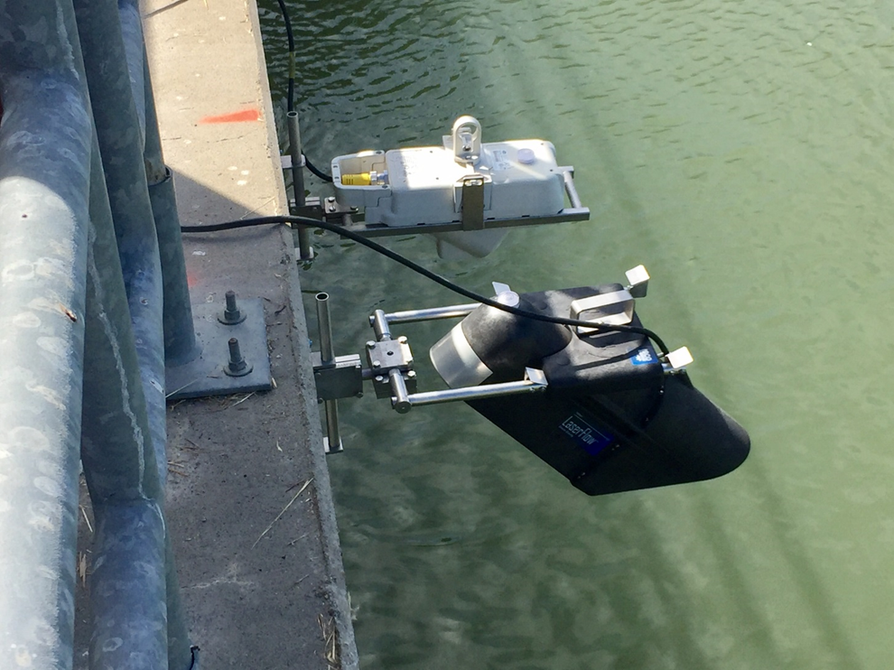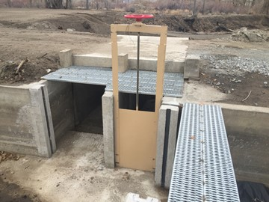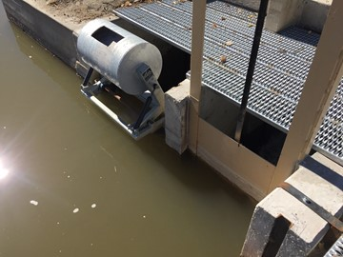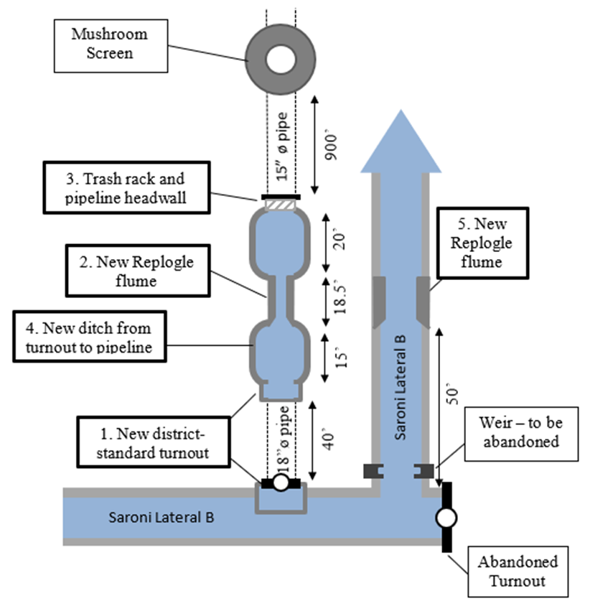

***Original Material Sponsored by the U.S. Bureau of Reclamation – California-Great Basin (Region 10)***

The Irrigation Training & Research Center (ITRC) at Cal Poly State University, San Luis Obispo, will be presenting a 3-day field course for staff, field operators, engineers, and board members of agricultural irrigation/water districts. This will be a custom class for operators can be designed for the conditions at northern Nevada irrigation districts.

**Course Topics**

**Flow Measurement – Pipelines**

Principles of flow measurement for open and closed systems; common measurement devices: propeller, magnetic meters, venturi, metergate; how to take accurate readings; address common accuracy issues. New material on magnetic meters.

**Flow Measurement – Canals**

Equations for canals; weirs and flumes; corrections for common problems; current metering techniques using traditional equipment as well as the new dopplers. New material on using gates for measurement.

**Canal Operations**

The service concept, including farmer constraints and needs; purposes of different check structures; water level vs. flow rate control; minimizing tail ender problem while still achieving good service; how to get more water through various structures; introduction to SCADA; interaction between canals and turnouts.

***Custom Class:***

***April 26-28, 2022 at the Walker River Irrigation District***

***8am - 3pm with breaks at 10:30 and Noon***

*Fee: $60/person for all U.S. irrigation districts; $450/person for participants from outside the U.S.  
All fees include class materials and software.

Registration:

In Person: WRID Office 410 N Main Street, Yerington, NV

Phone: (775) 463-3523

Email: [water@wrid.us](mailto:water@wrid.us)

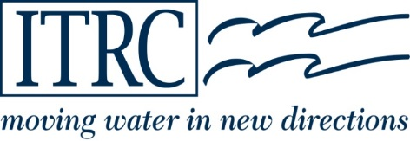

**IRRIGATION TRAINING & RESEARCH CENTER**

California Polytechnic State University

San Luis Obispo, CA 93407-0730 www.itrc.org